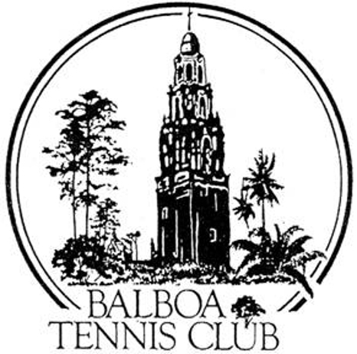
Balboa Tennis Club
Board of Directors Meeting Minutes

March 21, 2017

Meeting called to order at 7:02 p.m.

Attendees: Janene Christopher, Gary Smith, Julia Gregory, Ruben Carriedo, Esther Leeflang, M.A. Hillier, Colleen Clery Ferrell and Geoff Griffin.
Andrew Macfarlane - absent.
BTC member Larry Calder – non-presenting guest.

The Board voted unanimously to approve the minutes from the February 2017 meeting and board member absence.
Member/Guest Introduction: New BTC employee Robert Pe introduced himself to the Board. Robert grew up playing at “Morley Field” and is the younger brother of BTC member Maria Pe. He is the tennis coach at High Tech High for the boys and girls teams. Robert will be working both weekend evening shifts at the Reservations Office and cleaning the courts as well.
Tennis Director’s Report (Geoff Griffin)
- Non-Sanctioned BTC Spring tournament. Paid $87 to get the tournament on the USTA website so players can enter online and the “out-put” draws look professional. The challenge in using the on-line system is how to register non- USTA members. A work-around to “trick” system is being used for these 5-6 players to use on-line system.
- Tennis Fest plans are coming along with local icon and national celebrity Dick Enberg being honored with the Ben Press Award. Pam Shriver has agreed to introduce and present award. Tennis Fest shirts being printed with Enberg’s famous saying, “Oh My.”
- Board member M.A. Hillier is helping Wounded Warrior Camp with scheduling. This is the last time M.A. will perform this function. 61 campers have been selected (7 or 8 are repeat campers). The camp will take place one week after Tennis Fest.

Club Director’s Report (Colleen Clery Ferrell):
- Alan Bennett’s suggestion for downed trees in the park – The Native plant steward Alan Bennett is suggesting BTC offer $500 to City towards tree planting project across from parking lot. Board suggested Colleen contact Susan Mendoza for opinion on whether BTC should get involved.
- Timeline for online reservation system – A new 32x15 inch monitor has been installed at Reservations office. Members have until March 26 to submit email address for tennisbooking.com. First batch will be uploaded by tennisbookings.com on the 27th March. Members will then be able to create a personal password. Next step will be to allow members to see screen from user side (no reservation will be able to be made but they will see court availability). Projected date to “go live” is April 10.
- NIBCO review and 16/18 National Tournament –
  - NIBCO event was very successful in every aspect.
  - 16/18 National Committee Member is requesting lower court use fees. A motion was made and the Board agreed to a reduced rate of $8 /hr versus the usual $10/hr. with the additional verbiage in the letter /agreement stating: “Balboa Tennis Club is happy to enter into a relationship with the USTA 16/18 National Tournament and looking forward to expanding next year.”
- Membership Renewal Analysis for January/February 2017 (per Julia’s request) Excel spreadsheet with information on 177 phone calls that were made to members who had let their memberships lapse (moved-injured- not playing as much were some of the reasons). 19 people renewed. Board recommends making calls each month to expired members.
- Member request for BLOCK Court bookings – A large group of BTC members have requested to book 2 to 3 courts on Wednesday nights, adjacent to each other. They are requesting to be classified as a league.
Board discussion: The group is not a league. They can reserve courts adjacent to each other. The can reserve for time period allowed.
- Vacation from March 30-April 3 – approved
- Other Staff Issues - Sean Ortuno is filling in for Alex during medical time away. He will have to become familiar with the On-Line system.

Committee Reports
- Budget and Finance - (Julia Gregory) January and February Budget vs. Actual Report was inadvertently added to packet and would prefer to show month only.
Club was under budget. One of the reasons was less electrical usage due to rain. Memberships were up but daily permits were down due to rainy weather. Maintenance cost was for metal halide bulbs replacement.
Club is $6000 under budget for the year.
B. Facilities – (Janene Christopher)
Regreen and Brit-Court approved the financing for BTC.
The trip to LA/OC to review existing facilities with LED fixtures was cancelled to be rescheduled for June. Julia’s daughter has presented a fresh set of eyes regarding lighting upgrade for BTC. She recommends getting an electrical engineer on board from a design standpoint. Board looking at being able to self-fund more of light cost with Jack Grace trust money expected by year end.
We want to have a checks and balance to make sure lighting upgrade is done properly. Hiring an electrical engineer (lighting expertise) to design the system will insure we have looked at the system rather than just the fixture.
A motion was made and passed to spend up to $2000 for electrical engineer to assist in lighting upgrade planning.
C. Employment and Personnel: (Gary Smith)
The BTC Organization Chart protects everyone and allows for a smooth operation.
Additions are needed.
Board Discussion: Julia requested the Chart include categories for Organization Descriptions and use the Club Director’s Job Description as guide. The Org Chart and Club Director’s Job Description will be given to BTC Human Resource consultant Dianne St. John for review/edit.

Other Issues
A. Newsletter – May 2017 next publication

Unfinished Business
A. BTC Organizational Chart revision – Discussed earlier. Revision needed
B. More on Painting Electrical Box (adj to Ct 8) – Esther was inspired by stencil design at Bud Kearns Pool. Suggested pattern they use for electrical box painting. No action at this time.

New Business
- Challenge Court – Board agreed those who abuse Challenge Court rules would be suspended from using challenge court for up to a month.
- Unused Court Reservations – Julia asked Colleen to research how other clubs handle members who don’t show up for courts or do not call in to cancel their reservations.
Colleen: BTC has a “Wait List” - Attendants issue the “unused” court to wait -list players after two minutes. The unused court/No show for reservations has never been a problem at BTC. San Diego Tennis and Racquet Club, no penalty is enforced because the management doesn’t want to anger members. Colleen will check with other bigger clubs, see if any penalize members and report back to board with results.
- Memorial Day Parade (Kensington) Participation – Esther spearheading/organizing a group to participate in the Memorial Day Parade through the Kensington area. Geoff has giant tennis racquets he can loan them.

* Prior to adjournment, BTC President Janene Christopher thanked attendee Larry Calder for coming to the meeting and asked if he had any input. Larry mentioned he was recently appointed to the Southern Cal subcommittee for leagues and tournaments to enhance league play in San Diego. He has experience with Atlanta and Florida tennis associations.

Adjournment: 8:45 p.m.

NEXT MEETING is April 18, 2017

