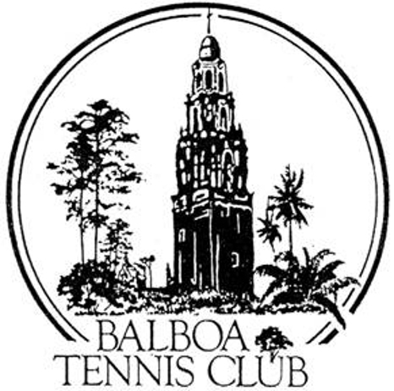
Balboa Tennis Club
Board of Directors Meeting Minutes

May 17, 2016

Meeting called to order at 7:00 p.m.

ATTENDEES: Janene Christopher (President), Gary Smith (Vice President), Julia Gregory (Treasurer), Andrew Macfarlane (Secretary), Ruben Carriedo, Esther Leeflang and Colleen Clery Ferrell (Club Director). Geoff Griffin (Tennis Director) and M.A. Hillier were absent due to the Wounded Warrior Camp.

The April 2016 meeting minutes and board absences were approved unanimously.

MEMBER/GUEST PRESENTATION – Trent Aaron – Teaching Pro with Griffin Tennis. Introduction- a competitive player for 30 years and a USPTA certified teaching pro for 20 years. He came to San Diego to study under Pete Egoscue [http://www.egoscue.com/] – methodology for stopping chronic pain and preventative methods for hip and knee replacements. Would like the Board to consider the installation of a Patch Fitness Obstacle Course across the parking lot from the Club - in the open grass area. City will have to approve. (this area is not included in the Special Use Permit the Club is currently operating under). There is a course at Torrey Pines High School. Will distribute via e-mail to Board Members a short video for further explanation and provide additional information for consideration.
Here is also an online explanation of Patch Fitness.“Why a Patch Fitness Obstacle Course Functional Fitness has become the “buzz” word in the fitness industry because we have discovered the necessity for our exercises to be more supportive of the actual movements that we do on a daily basis. Functional fitness involves movements that replicate how the body moves while doing real life activities, whether you are dancing, walking, running, climbing, crawling, ducking, jumping, shoveling snow, cleaning house, or playing games or sports in your back yard, on the playground, playing court or field. Functional fitness is improved by adding agility, balance, coordination, and dexterity to a fitness base of muscular strength and endurance, cardiovascular endurance and flexibility. Patch Fitness focuses on functional fitness. The end result will be improved body composition decreased body fat and increased lean body mass. “
Action: Colleen to distribute link to on-line video

President's Comments ( Janene Christopher) See Committee Report “Facilities”

Tennis Director’s Report (Geoff Griffin) Unable to attend the meeting due to Wounded Warrior Camp.

Club Director’s Report (Colleen Clery Ferrell)

- New inscriber for donor brick project – Six new bricks to be inscribed and installed. Dan Hays assisting with delivery.
- Successful bee removal from Clubhouse – cost $700 to re-locate bees [No poisons or chemicals used].
- Member laspsed renewals – Long-time member negligent in m/ship renewal since 2013. Encouraging employees to be more diligent about regularly verifying memberships.
- Landscape challenge – Dan and Melissa working separate shifts now to avoid conflicts. Gary observed diligent work of Melissa and reinforced positive work ethic.
- Retirement Program – Meeting with Julia and Club CPA Jere Batten. Two employees will participate, two others declined. Starts in July.
- Muan’s bench – Installed earlier in the day prior to Board Meeting. Thanks to Esther for collecting funds. Plaque and flower pots to follow – also funded by “Friends of Muan”. Esther will consult with Dan Hays regarding type of pots and flowers best suited for location.
- Lost and Found items – now listed on Daily Log (suggestion from Alex).
- Daily Log Notes – Incident in Clubhouse during an event. Club House use will be mentioned in “Weekly Update” and will advise members they may be asked to move to another area of the room or possibly to vacate Clubhouse during planned events.

Committee Reports

- Budget and Finance (Julia) Finances at BTC going well. A good system is in place with attention to detail. Income is better than last year and expenses are in line. With an old facility, repair and maintenance are mindfully in the budget. Year to date, income budgeted for $115,000, yet actual figure is $125,000. Everything is looking good and under budget.
- Facilities (Janene)
- Tournament Pavilion -
  - Pavers for pavilion project – Colleen : Three estimates received. Recommend the lowest bidder who gave $2600 discount. Board Discussion. –Action: Unanimous vote to move forward with recommended contractor and installation (after National Open Tournament).
  - Discussion on Naming Pavilion: No action taken..
- Shade Canopy - Leagues have requested a canopy above/overlooking Courts 22-24. Colleen will get bid for canopy similar to one on the north end.
- Shed Roof Repair - Details on repairing Geoff’s shed still being worked out.
- LED Lighting - upgrade of Stadium lights will cost $9,800 (10 new – 444W LED) fixtures. This could be the show court to exemplify the degree of improvement that new LED lighting on upper courts could provide. Budget for lighting upgrades will be discussed at June meeting.
- Constitution and Bylaws – None
- Employment and Personnel – Sean Ortuno and Jeff Anderson are no longer on the BTC payroll.
- Ethics – Upcoming BTC League and Meet the Pros Meeting – Esther :An opportunity for members to bring up concerns and questions. Colleen will post sign at Reservations Desk announcing meeting. Announcement on Club Update has been posted for a month.

Contract and Lease

- SUP Update - Janene has contacted Steve Hill, Deputy Chief of Staff -Todd Gloria’s office to request Todd’s assistance in getting the SUP signed. Janene & Colleen also has e-mail communication with Susan Mendoza. E-mails justified benefits of $10/ day adult fee vs. $5/ hour adult fee. They cited the benefits BTC has to offer for the $10 fee. No response to date.
- Cafe – Ohana Cafe contract on hold pending City SUP decision. Discussion on having “food service” for National Open. Ohana will use a traveling permit.
  - Action: Board Vote- 4 yes, 2 absent, 1 abstain.

Other Issues

- Newsletter – Published May 1. Next edition in November.
- Youth program – None
- Website – None
- Advertising/Public Outreach – None
- Fundraising – None

Unfinished Business

- PayPal for website – Colleen and Paula working on logistics.
- Tournament Pavilion name – See Committee Report “Facilities”.

New Business

- Clubhouse Shade – BTC member offering to pay for window shades/window coverings in clubhouse. Colleen will get quotes for roller shades.
- Shade above Courts 22-24 – See Committee Report “Facilities”.
- Etiquette List – suggested by Vicki Padilla – Board agreed list put together by Vicki is covered by BTC on sign entering court and also overlaps Rules and Regulations as well as FAQ on website. No additional signs at this time.
- Liability Form & Guest Pass at Reservations – Julia suggested getting a [triplicate] form that combines liability waiver and permittee info (Name & Fee payment). Will follow up at June meeting.

Adjournment: 8:23 p.m.

The next board meeting will be June 21, 2016

