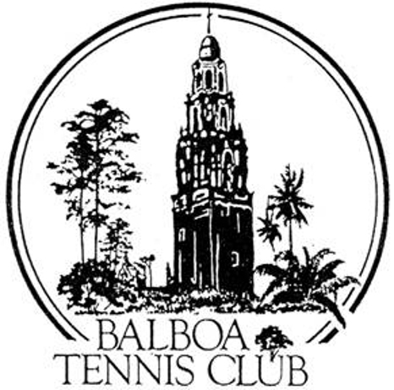
Balboa Tennis Club
Board of Directors Meeting Minutes

August 15, 2017

Meeting called to order at 7:03 p.m.

Attendees: Janene Christopher, Gary Smith, Julia Gregory, Andrew Macfarlane, Esther Leeflang, Ruben Carriedo, Colleen Clery Ferrell, and Geoff Griffin.

M.A. Hillier was not in attendance.

The July 18, 2017 meeting minutes were approved unanimously.

Member/Guest presentation – Louis Porro was scheduled to speak but didn’t show up or call to explain absence.

President's Comments (Janene Christopher)
- Janene explained her review of options for new lighting. The very best lighting situation will require new poles and wiring run to poles between courts. Ruben expressed his concern about safety for players if poles are placed between courts. Board discussed options such as soft covering for poles for added safety.

Tennis Director’s Report (Geoff Griffin)
- BTC Open and BTC Junior tournament were a success. Entries were slightly down this year but tournaments were both revenue positive. Junior entries likely down due to another tournament scheduled for the same weekend in Los Angeles and SCTA rule allows entry in only one tournament at a time.
- Free clinic went well. 16 persons signed up but only 9 showed up for the clinic. Sales pitch for club membership to be included with future clinic.

Club Director’s Report (Colleen Clery Ferrell)
- Girl’s 16/18 Nationals played at BTC for the first time. Tournament was overall a great success. Everything ran smoothly at Balboa courts. Tournament director was so happy with BTC that more courts are requested for next year’s tournament. Players asked for additional practice courts, but difficult to accommodate after reservations for match courts and member reservations.
- The city will be trimming trees planned for Aug 23 and 24. Some courts will be temporarily unavailable for safety reasons during trimming. City will also be replacing selected doors at Reservations Office.
- Social Media Director – letter to Julie thanking her for service and offer to continue membership for her and daughter in exchange for continued social media activities.
- A member suggested having all four players exit Challenge Court on busy days so more players can compete. Board denied request because it would take away from competitive element of Challenge Court which is basis for court existence.
- Membership at 1205. Colleen encouraging new memberships. Renewal rates occasionally offered to new members to encourage new sign ups.

Committee Reports
Budget and Finance (Julia)
  - Past month income under budget, however club is right on track for year with income projections.
  - $146,000 in bank, well above $50,000 target in part due to recent donation received from Jack Grace. Additional donation income expected by year end.
  - Suggested newsletter topic explaining the importance of tournaments at the club as a public service and also income to keep membership costs low, thus allowing for capital improvements. Tournaments also add prestige to the Club and Geoff commented it was a duty of BTC to support the tournaments.
  - Ruben commented that he feels confident about making decisions because Julia has the finances under control.
Facilities (Janene)
  - Shade for courts 8 and 9 considered. Presently there are no shaded benches for players to rest. Concern raised by parents at Girls’ 16/18 Nationals.
  - Shade for players on stadium installed. Court 1 shade forthcoming, yet approved.

Constitution and Bylaws - None

Employment and Personnel – Jacob is leaving for college. Shaun will take over additional shifts. Colleen’s time away for Intersectionals in November approved
.
Ethics – None

Contract and Lease

- Cafe – Becky will continue with café for District and Metro tournaments.
Guillermo notified that Becky will vacate early October. Guillermo still wants to take over the café space and invest in an ongoing business.
BTC will need to get café certified up to code by the city.
City will be notified of change by letter.

Other Issues

- Newsletter - Next newsletter is November. Will include article about tournaments at the club as discussed earlier at this meeting.
- Website – link to online court reservation system is now included on BTC website.
- Advertising/Public Outreach - San Diego Aviators tickets sold out, with complimentary tickets going to Julie Prichard and Roberto Ancira.

Unfinished Business
- Clubhouse roof – City roofers took measurements and stated the repairs will be made before rainy season but no actual confirmation date given.
- Tournament Pavilion – discussion as to what we should budget. Cost depends on design, necessity of class A contractors. Possible phases for project to manage construction costs. Janene contacted a structural engineer and has agreed to do drawing.

New Business
- New business – proposal made to Ron Marquez for court rental ($5/hr/court) and stipulation that all used balls donated to Griffin Tennis Junior Program. Colleen will meet with CIF officials to sign agreement.

Adjournment: 8:16 p.m.

Next board meeting will be September 19, 2017

