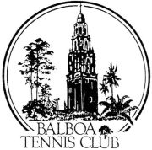

DIRECTOR’S REPORT
January 19, 2016

- Wild Card for National Open – Lost the wild card three years ago. Taken away by USTA. Trying independently along with referee and local umpires to get one back. Secured female spot in local $25,000 tournament for 2017 at Morgan Run Country Club. Still working on wild card for men’s open winner. Brings overall tournament numbers up.
- San Diego Slam – La Jolla tournament director not very excited. Waiting until Metro 2016 settles and then may work on individual sponsor.
- Court washing around County – Contacted Lake Murray, Peninsula, San Diego Tennis and Racquet Club, La Jolla Rec and PB Tennis Club. Wash as needed basis. Blow daily. Mobile service around county charges $25 per court.
DAILY LOG OVERVIEW

- On 1/13/16 – BTC Member Charles Griffin suffered a heart attack on the tennis court. Charles had previously informed BTC management staff of heart condition and inability to have AED hooked up. Staff and members very helpful getting ambulance and victim off to the hospital.

Colleen Clery Ferrell Vacation and Sick Pay totals:

Vacation Balance: 16.16
Sick: Balance: 48.16

